**CLASS TEST – CSA0960**

**K. EDUKONDALU**

**192365010**

1. **Write a program that will take in the base and height of a triangle and calculate and display the area of the triangle using the formula below.**



**CODE:**

package com.example;

public class TriangleArea {

public static void main(String[] args) {

double base = 3;

double height = 2;

double area = (base * height) / 2;

System.*out*.println("The area of the triangle is: " + area);

}

}

**OUTPUT:**

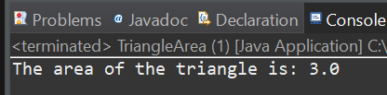

1. **Write the following math formulas in Java. You will need to use methods from the Math class as well as nesting of methods and parentheses to force the order of operations to correctly calculate the answer. Assume that all the variables in the formulas have already been declared and initialized.**

package com.example.mathformulas;

public class MathFormulas {

public static void main(String[] args) {

double x = 3;

double y = 4;

double z = 2;

double a = Math.sqrt((Math.pow(x, 5) - 6) / 4);

System.out.println("a = " + a);

double b = x * y - 6 * x;

System.out.println("b = " + b);

double c = 4 * Math.cos(z / 5) - Math.sin(Math.pow(x, 2));

System.out.println("c = " + c);

double d = Math.pow(x, 4) - Math.sqrt(6 * x - Math.pow(y, 3));

System.out.println("d = " + d);

double e = 1 / (y - 1 / (x - 2 * y));

System.out.println("e = " + e);

double f = 7 * Math.cos(Math.sqrt(5 - Math.sin(Math.sqrt(3 * x - 4))));

System.out.println("f = " + f);

}

}

**OUTPUT:**

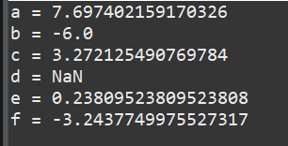

1. **A bus holds 45 people. The school will only use a bus if they can fill it completely. The rest of the people will ride in vans. Write a program that will take in the number of people that are signed up to go on a field trip. Have the program print the number of busses necessary and then total number of people that will need to ride in vans**

package buscapacitycal;

import java.util.Scanner;

public class buscapacity {

public static void main(String[] args) {

Scanner sc = new Scanner(System.in);

System.out.print("Enter the number of people: ");

int people = sc.nextInt();

int busCapacity = 45;

int buses = people / busCapacity;

int vans = people % busCapacity;

System.out.println("Number of buses needed: " + buses);

System.out.println("Number of people needing to ride in vans: " + vans);

sc.close();

}

}

**OUTPUT:**

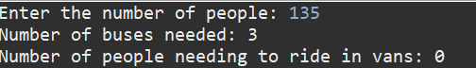

1. Given the three String objects below, what will each of the following return?

String s1 =“ABC”;

String s2 = new String(“DEF”);

String s3 = “AB” + “C”;

a. s1.compareTo(s2);

b. s2.equals(s3);

c. s3 == s1;

d. s2.compareTo(s3);

e. s3.equals(s1);

**CODE:**

package com.example.stringconcatenation;

public class StringConcatenation {

public static void main(String[] args) {

String s1 = "ABC";

String s2 = new String("DEF");

String s3 = "AB" + "C";

System.out.println("s1.compareTo(s2): " + s1.compareTo(s2)); // a

System.out.println("s2.equals(s3): " + s2.equals(s3)); // b

System.out.println("s3 == s1: " + (s3 == s1)); // c

System.out.println("s2.compareTo(s3): " + s2.compareTo(s3)); // d

System.out.println("s3.equals(s1): " + s3.equals(s1)); // e

}

}

**OUTPUT:**

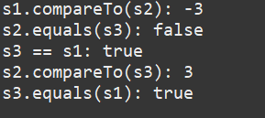

1. Write a program that prompts the user to enter two floating point (double) numbers and an operator ( *, +, /, %, -). Print the results of the given operation. For reading the command line, use the Scanner class. Write the program first using switch logic, then re-write the program using if/else logic.

**CODE:**

import java.util.Scanner;

public class Calculator {

public static void main(String[] args) {

Scanner scanner = new Scanner(System.in);

// Prompt the user for input

System.out.print("Enter first number: ");

double num1 = scanner.nextDouble();

System.out.print("Enter second number: ");

double num2 = scanner.nextDouble();

System.out.print("Enter an operator (*, +, /, %, -): ");

char operator = scanner.next().charAt(0);

// Using switch logic

System.out.println("Switch logic result:");

switch (operator) {

case '+':

System.out.println("Result: " + (num1 + num2));

break;

case '-':

System.out.println("Result: " + (num1 - num2));

break;

case '*':

System.out.println("Result: " + (num1 * num2));

break;

case '/':

System.out.println(num2 != 0 ? "Result: " + (num1 / num2) : "Cannot divide by zero.");

break;

case '%':

System.out.println(num2 != 0 ? "Result: " + (num1 % num2) : "Cannot divide by zero.");

break;

default:

System.out.println("Invalid operator.");

}

// Using if/else logic

System.out.println("\nIf/else logic result:");

if (operator == '+') {

System.out.println("Result: " + (num1 + num2));

} else if (operator == '-') {

System.out.println("Result: " + (num1 - num2));

} else if (operator == '*') {

System.out.println("Result: " + (num1 * num2));

} else if (operator == '/') {

System.out.println(num2 != 0 ? "Result: " + (num1 / num2) : "Cannot divide by zero.");

} else if (operator == '%') {

System.out.println(num2 != 0 ? "Result: " + (num1 % num2) : "Cannot divide by zero.");

} else {

System.out.println("Invalid operator.");

}

scanner.close();

}

}